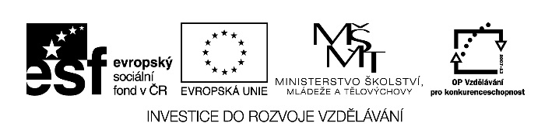

Autorem materiálu a všech jeho částí, není-li uvedeno jinak,
je Melicharová Eva.

Dostupné ze Školského portálu Karlovarského kraje www.kvkskoly.cz, materiál vznikl v rámci projektu Gymnázia Cheb s názvem Rozvoj školského portálu Karlovarského kraje

Příklady přípravy některých druhů bílých polévek:
Napiš technologické postupy u bílých polévek:

Zeleninová polévka: .
Technologický postup: ----------------------------------------------------------------------------------------------------------------------------------------------------------------------------------------------------------------------------------------------------------------------------------------------------------------------------------------------------------------------------------------------------------------------------------------------------------------------------------------------------------------------------------------------------------------------------------------------------------------------------------------------------------------------------------------------------------------------------------------------------------------------------------------------------------------------
---------------------------------------------------------------------------------------------------------------------

Bramborová polévka:
Technologický postup:--------------------------------------------------------------------------------------------------------------------------------------------------------------------------------------------------------------------------------------------------------------------------------------------------------------------------------------------------------------------------------------------------------------------------------------------------------------------------------------------------------------------------------------------------------------------------------------------------------------------------------------------------------------------------------------------------------------------------------------------------------------------------------------------------------------------------------------------------------------------------------------------------------------------------------------------
---------------------------------------------------------------------------------------------------------------------
---------------------------------------------------------------------------------------------------------------------

Selská polévka:
Technologický postup:--------------------------------------------------------------------------------------------------------------------------------------------------------------------------------------------------------------------------------------------------------------------------------------------------------------------------------------------------------------------------------------------------------------------------------------------------------------------------------------------------------------------------------------------------------------------------------------------------------------------------------------------------------------------------------------------------
---------------------------------------------------------------------------------------------------------------------

Čočková polévka:
Technologický postup:--------------------------------------------------------------------------------------------------------------------------------------------------------------------------------------------------------------------------------------------------------------------------------------------------------------------------------------------------------------------------------------------------------------------------------------------------------------------------------------------------------------------------------------------------------------------------------------------------------------------------------------------------------------------------------------------------------------------------------------------------------------------------------------------------------------------------------------------------------------------------------------------------------------------------------------------
---------------------------------------------------------------------------------------------------------------------

